|  |  |
| --- | --- |
|  | Integrated System for Measuring Road Roughness |
|  |  |
|  | Iven  ENEL 417  1/18/19 |

# Project Description

Saskatchewan Ministry of Highways and Infrastructure currently spends close to half a million dollars annually to gather surface roughness and overall condition data of over 20,000 km of highways. The City of Regina uses also uses a similar system to gather data from major city roads every three years. We plan to minimize this cost by building a low cost and modular system that can be used to take measurements of the road roughness and can be used to supplement the more expensive equipment to map all of the roadways. This system will also be able to support the measurement of road surface roughness where data is not currently being collected such as smaller rural municipalities roads and residential city roads. The measurement of road roughness along with images that provide visual reference are used to quantify road surface conditions.

The system uses two roughness sensors (accelerometers) mounted directly over the two back wheels in a car that transmit real time roughness data wirelessly to a central terminal situated in the car. The car position is tracked with a GPS sensor that organizes the data transmitted to the central terminal with location coordinates of the car. At the same time a camera, attached to the central terminal, captures images of the road surface and the surroundings as the car is moving. The captured roughness and image data are stored in the central terminal. Afterwards, automated scripts process the data using digital signal processing tools to analyze the accelerometer and image data to extract usable information from the data. The required information is stored on the central terminal, which also acts as a server to upload the required data to a website. The website is used to display the information regarding road roughness and conditions in an intuitive and accessible format.

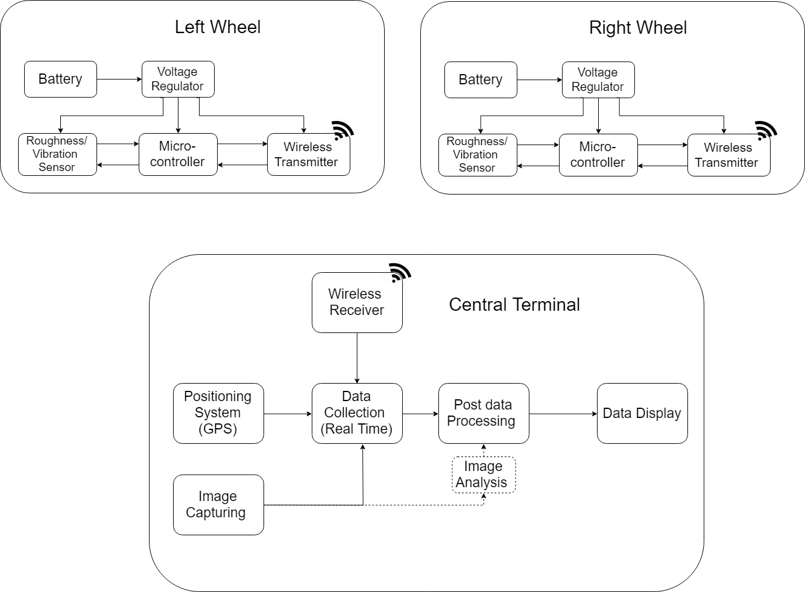

# Project Design Specification

The project design specifications are described for each subsystem as follows:

**Roughness Sensor/Analysis**

* Designed to be able to detect and characterize roughness of at least 5 cm vertical displacement over a 30 cm length of the road
* Proper characterization of the road requires sensors to be able to sample at least 1 m long section of the road at the posted speed limit of the road under normal condition
  + 100 km/h = 27.78 m/s -> 27.8 samples/sec – minimum sampling rate of 30 samples/sec required (may sample higher if required)
* Noise and other variables such as car speed, or car suspension system dynamics are either minimized or controlled in order to get a true indication of road surface roughness
* Comparison with data logged from a cell phone accelerometer to ensure that calibration is accurate (±10 %)

**Wireless Data Transmission**

* Data rate for the system should be below the maximum allowable transmission rate by the wireless transmission (minimum 30 samples/sec*16 bits/sample = 480 bits/sec = 60 bytes/sec minimum required data rate)
* Receiver is able to simultaneously receive two separate incoming signals from both left wheel and right wheel and is also able to discriminate between the signals
* Adequate range to reach the receiver attached to the central processing unit (tested inside the car where system will be mounted)
* Signal interference should be minimized (signal transmitted == signal received)

**Positioning System (GPS)**

* GPS takes a minimum of one sample per second to precisely determine where the car is
* Positioning system maintains a similar accuracy (±20 %) as a cell phone GPS to accurately map out the car’s position on the road

**Image Capture/Analysis**

* Images are captured fast enough to capture the whole road surface: image taken every 10 meters (max speed 30 m/s, requires minimum of 3 pictures/second)
* Image analysis is able to identify at least 75% of major cracks/potholes in the road surface

**Battery/Voltage Regulator**

* Able to provide power to the components for a minimum of one hour of charge time
* Voltage regulator is able to provide the necessary voltage to power the connected device (3.3 V ± 10%)

# Project Testing Plan/Requirements

The project testing requirements and workload is divided based on the following block diagram showing various parts of the project, their interactions and the workload shared among the group members.

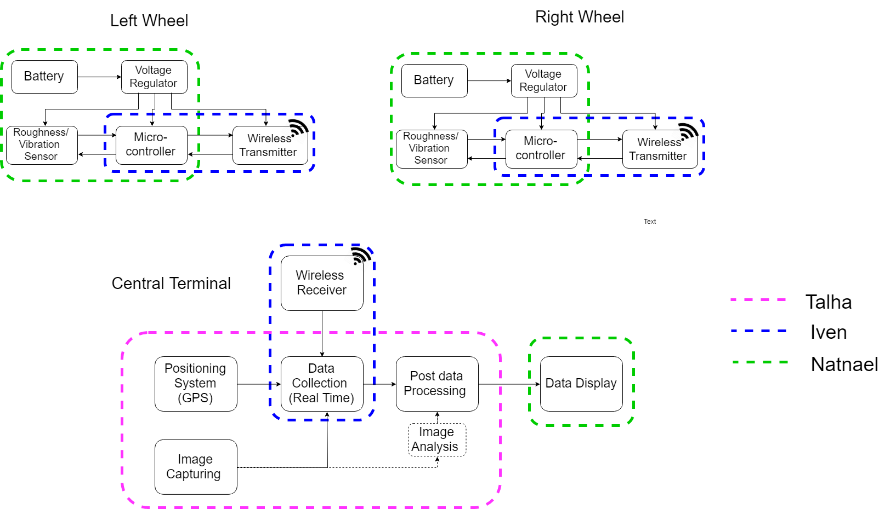

**Roughness Sensor/Analysis Testing**

Testing roughness sensor will entail that basic functionality such as being able to communicate with the device is tested all the way to being able to read acceleration values from the sensor.

1. Write test code/initialization to read device ID and output it to terminal to ensure basic communication with the device is established.
2. Output data to terminal and check if acceleration data is correctly being read and sample rate is as specified (essentially move accelerometer up and down and observe changing of data).
3. Log accelerometer data and compare logged data with data captured with a phone accelerometer to ensure sensor is roughly calibrated/measured against a known reference.
4. Test accelerometer by moving the sensor through various vertical bumps placed on a moving object such as a cart and checking if accelerometer results correspond to the vertical movement experienced by the sensor (minimum requirement to characterize 5 cm of vertical movement over 30 cm of horizontal movement).
5. Test accelerometer at rest and test what the effects of noise are on the system.
6. Test accelerometer in the car at different speeds on the same road surface to see if effects of car speed are eliminated from the analyzed data.

**Wireless Data Transmission Testing**

1. Test data transmission by sending minimum of 60 bytes/second from one Xbee communication device to another and checking if data transmission rate is adequately achieved (tested using XCTU tool).
2. Simultaneously transmit two different messages from each transmitter to the Xbee receiver and check if messages received can be differentiated based on sender.
3. Test Xbee device communication inside the car to ensure there is no packet loss, range is adequate and messages sent are the same as the messages received.

**GPS Testing**

1. GPS signal is tested for accuracy in comparison to a known reference, most likely cell-phone or other reference, if available. Latitude and longitude coordinates are logged and compared with an error rate calculated to ensure it is with performance specifications.
2. GPS data is logged with respect to time signal in order to ensure that sample rate is adequate.

**Image Capture Testing**

1. Mount camera in car travelling on road and test images taken to see if the whole road surface is being captured (every 10 m long section of the road)
2. Compare captured images to images analyzed using DSP and find what percentage of major potholes in the road are identified.

**Battery Testing**

1. Run system for at least 1 hour and test if battery performance meets specification.
2. Test regulated voltage using multimeter to ensure it meets specification for voltage (3.3 V ±10%).

# 4.0 gANTT cHART

